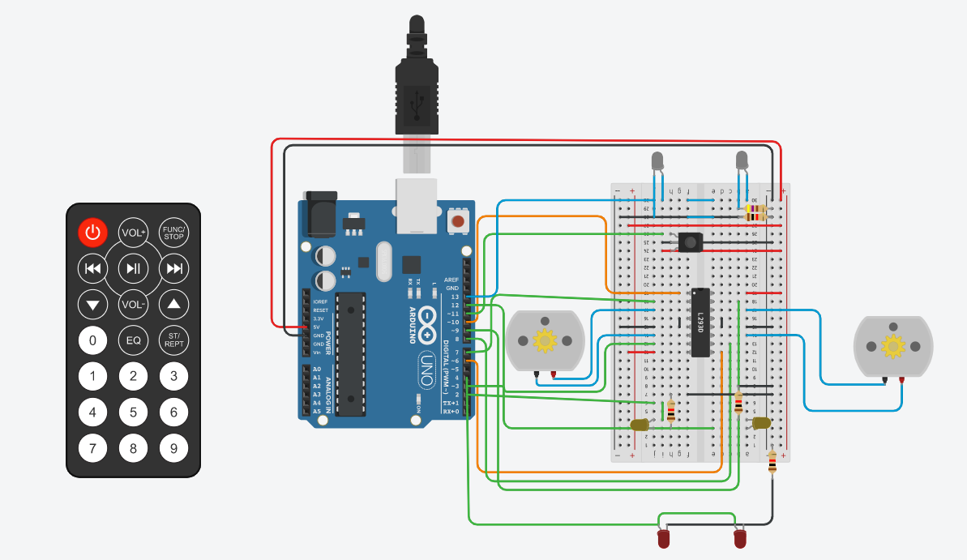Final Project

#include <IRremote.h>

//Init IR sensor

IRrecv rc(11);

decode_results results;

//Init Motors

const int PWM_M1 = 10;

const int IN1_M1 = 7;

const int IN2_M1 = 3;

const int PWM_M2 = 6;

const int IN1_M2 = 8;

const int IN2_M2 = 9;

int speed = 100;

//Init the lights

const int Back_Light = 4;

const int Front_Light = 13;

const int Left_Light = 2;

const int Right_Light = 12;

void setup(){

Serial.begin(9600);

rc.enableIRIn();

//Setting the pinmodes

pinMode(PWM_M1,OUTPUT);

pinMode(PWM_M2,OUTPUT);

pinMode(IN1_M1,OUTPUT);

pinMode(IN2_M1,OUTPUT);

pinMode(IN1_M2,OUTPUT);

pinMode(IN2_M2,OUTPUT);

//initalizing every pin to zero

digitalWrite(IN1_M1, LOW);

digitalWrite(IN2_M1, LOW);

digitalWrite(IN1_M2, LOW);

digitalWrite(IN2_M2, LOW);

digitalWrite(Front_Light,LOW);

digitalWrite(Back_Light,LOW);

digitalWrite(Left_Light,LOW);

digitalWrite(Right_Light,LOW);

}

void loop(){

if (rc.decode(&results)){ //Reading the receiver value

switch(results.value){// calling the appropriate function according to the value read

case 0xFD807F://vol+

forward();

break;

case 0xFD20DF://|<<

turnLeft();

break;

case 0xFDA05F://>||

stop();

break ;

case 0xFD609F://>>|

turnRight();

break ;

case 0xFD10EF://down arrow

speedDown();

break ;

case 0xFD906F://vol-

backward();

break ;

case 0xFD50AF://up arrow

speedUp();

break ;

}

rc.resume();

}

}

void forward(){

Serial.println("forward");

Serial.println("Head Light ON");

digitalWrite(Front_Light,HIGH); //switching on the Head Light

digitalWrite(Back_Light,LOW);

// Setting the motor on the desired value

analogWrite(PWM_M1, speed);

analogWrite(PWM_M2, speed);

digitalWrite(IN1_M1, HIGH);

digitalWrite(IN2_M1, LOW);

digitalWrite(IN1_M2, HIGH);

digitalWrite(IN2_M2, LOW);

}

void backward(){

Serial.println("backward");

digitalWrite(Front_Light,LOW);

Serial.println("Head Light OFF");

digitalWrite(Back_Light,HIGH); //Switching on the tail light

analogWrite(PWM_M1, speed);

analogWrite(PWM_M2, speed);

digitalWrite(IN1_M1, LOW);

digitalWrite(IN2_M1, HIGH);

digitalWrite(IN1_M2, LOW);

digitalWrite(IN2_M2, HIGH);

}

void turnLeft(){

Serial.println("turnLeft");

digitalWrite(Left_Light,HIGH);

analogWrite(PWM_M1, 0);

analogWrite(PWM_M2, speed);

digitalWrite(IN1_M1, LOW);

digitalWrite(IN2_M1, LOW);

digitalWrite(IN1_M2, HIGH);

digitalWrite(IN2_M2, LOW);

digitalWrite(Left_Light,LOW);

}

void turnRight(){

Serial.println("turnRight");

digitalWrite(Right_Light,HIGH);

analogWrite(PWM_M1, speed);

analogWrite(PWM_M2, 0);

digitalWrite(IN1_M1, HIGH);

digitalWrite(IN2_M1, LOW);

digitalWrite(IN1_M2, LOW);

digitalWrite(IN2_M2, LOW);

digitalWrite(Right_Light,LOW);

}

void stop(){

Serial.println("stop");

digitalWrite(Back_Light,HIGH);

digitalWrite(IN1_M1, LOW);

digitalWrite(IN2_M1, LOW);

digitalWrite(IN1_M2, LOW);

digitalWrite(IN2_M2, LOW);

}

void speedUp(){

Serial.println("speedUp");

speed+=10;

if(speed>255) speed =255;

analogWrite(PWM_M1, speed);

analogWrite(PWM_M2, speed);

}

void speedDown(){

Serial.println("speedDown");

digitalWrite(Back_Light,HIGH);

speed-=10;

if(speed<0) speed =0;

analogWrite(PWM_M1, speed);

analogWrite(PWM_M2, speed);

digitalWrite(Back_Light,LOW);

}